UNIT-I
Broad Classification of the Animal Kingdom – Concepts of species, hierarchial taxonomy.

Protozoa
Feeding - Locomotion, Reproduction and Parasitic adaptations of Rhizopoda, Mastigopora, Ciliophora, Saprozoans and Mycetozoa with suitable examples. Economic importance with respect to Health aspect of Soil, Fresh water and Marine Protozoans, Osmoregulation in Protozoa. Theories on Origin and evolution of Metazoa – Syncytial, Colonial and Polyphyletic theories.

Porifera

Functional morphology of freshwater sponges with suitable example. Inter relationship between different classes. Marine sponges. Reproduction – Asexual and Sexual, Regeneration in sponges. Systematic position and Affinities of sponges.

Broad classification of the Animal Kingdom

Animal Kingdom
Scientists predict that only 15% of species are known to man from the estimated 8.7 million species. That leaves almost 85% species yet to be discovered. Only about 953,434 species of animals have been catalogued in the Animal Kingdom. Let us study this classification of animals.

Classification of Animals and Plants
There are millions of living organisms in this world. There are some which are even yet to be discovered. These living organisms that are known to man, very broadly include animals, plants, microorganisms etc. All of them show great diversity. Yet, there are some characteristics that are similar between groups of organisms and this is what binds them together.
Classification of animals helps us to understand their characteristics, as well as their differences with other organisms. The best-known organisms are the animals. In scientific terminology, they are grouped under the Kingdom Animalia, better known as the Animal Kingdom. Let us learn more about this famous Kingdom!

Animal Kingdom
Kingdom Animalia consists of organisms that range from the simplest of the animal forms to the most complex. At one end of this classification of animals, you have the microscopic organisms. And at the other end, you see animals that you probably come across in your daily life. You and your friends, for example, are members of the Animal Kingdom. Your pet dog, bird, cat or even those pesky insects that you find in the gardens are all part of this gigantic kingdom.
Scientifically speaking, all organisms that belong to this Kingdom are Eukaryotic organisms. They are all multicellular, with many cells present. The cells do not have cell walls in them. Another important feature is that they have a heterotrophic mode of nutrition, which means that they cannot make their own food.

The Different Phyla
Classification of animals is termed as Kingdom Animalia. It is further divided into different phyla. These are nothing but divisions in which animals/organisms with the same characteristics are included under them. Apart from the primary distinguishing features of the Animal Kingdom (Eukaryotic, Multicellular, without a cell wall and heterotrophic); each phylum has organisms that have common characteristics. In the classification of animals chart, they move from the simplest to the most complex.
The different phyla in the classification of animals are as follows:
- Phylum Porifera
- Phylum Coelenterata
- Phylum Platyhelminthes
- Phylum Nematoda
- Phylum Annelida
- Phylum Arthropoda
- Phylum Mollusca
- Phylum Echinodermata
- Phylum Protochordata
- Phylum Vertebrata
Let us now look at some important features of each Phylum.

Phylum Porifera
These are the simplest multicellular animals, found mainly in marine habitats. These organisms have pores all over the body. They have a canal system that helps in circulating water and food particles and oxygen. The body design shows minimal differentiation and division of tissues. Commonly called as Sponges, some of the examples are Spongilla, Sycon etc.

Phylum Coelenterata
These organisms show more body differentiation. They live in water. The body has a sac-like cavity, with a single opening for ingestion an egestion. These animals have two germ layers and hence are called diploblastic. You can see these animals living solitarily or n colonies. Examples include Jellyfish, Sea Anemone, and Hydra.
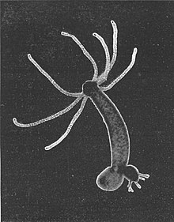

Phylum Platyhelminthes
These are commonly called flatworms. Their bodies are flattened dorsoventrally. They are the first triploblastic animals, with three germ layers. The body is also bilaterally symmetrical, with both the left and right halves of the body having the same design. Flatworms can be either parasitic or free living. A few examples are Planaria, Liver Fluke, and Tapeworm.

Phylum Nematoda
The bilateral symmetry and triploblastic nature continue in these animals. The body, however, is more cylindrical and not flattened. The body cavity is not a true coelom. And hence it is called a pseudo coelom. Tissues are present, but organs are absent. These organisms show a complete alimentary canal which is straight. Most of these organisms belonging to this phylum are parasitic worms, which cause diseases. Examples are Ascaris, Wucheria.

Phylum Annelida
Annelids are found in different habitats, such as land, fresh water, and even marine mater. They have a bilaterally symmetrical body with three germ layers (Triploblastic). A distinguishing feature here is that they have a true body cavity. The body is also segmented with some organ differentiation seen. Examples are Earthworms, Leeches.

Phylum Arthropoda
They make up the largest group in the animal kingdom. Most of the insects are included in this phylum. “Arthropoda” means jointed legs. The bodies of these animals are divided into head, thorax, and abdomen. Apart from the jointed legs, they also have a pair of compound eyes. Another distinguishing feature of these animals is the presence of an open circulatory system. Examples are butterfly housefly, spiders, mosquitoes, crabs etc.

Phylum Mollusca
The bilateral symmetry and the triploblastic nature of the body layers are seen here too. Molluscans form a very diverse group and form an important part of the ecosystem. These animals can be seen aquatic habitats. They can be either marine or freshwater species. The body does not show much segmentation and the coelomic cavity is also reduced. The body is typically divided into anterior head, ventral muscular foot, and a dorsal visceral mass. The foot helps in the locomotion of the animals. Examples are Snails, Mussels, and Octopus.

Phylum Echinodermata
Moving on with the classification of animals we come to Phylum Echinodermata. Echinoderms are animals with spiny skin. They live exclusively in a marine habitat. They are free-living animals. The larvae show bilateral symmetry whereas the adults show radial symmetry. These animals are triploblastic and have a coelomic cavity. They have a peculiar water driven tube system that helps them in moving around. They also have a hard exoskeleton that is made up of calcium carbonate. Examples are Starfish, Sea cucumber, Sea Urchin.
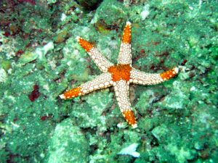

Phylum Protochordata
The protochordate animals are bilaterally symmetrical and triploblastic. They have a coelom. A new body feature that is seen in these animals is the presence of notochord at some stage in their life cycle. Due to this very presence of a notochord, they are called as chordates. However, it is sometimes rudimentary. They are exclusively marine animals. Examples include Herdmania, Balanoglossus.

Phylum Vertebrata
These are the advanced group of animals, showing some really advanced features of a proper digestive system, circulatory system etc. There is a complex differentiation of body tissues and organs. These animals have a true vertebral column with an internal skeleton. All chordates have the following features:
- Notochord
- Dorsal Nerve Cord
- Post-anal tail
- Pharyngeal slits
Phylum Vertebrata is classified into five classes. They are:
- Pisces
- Amphibia
- Reptilia
- Aves
- Mammalia

Class Pisces
These are exclusively aquatic animals, commonly called as Fish. Their skin is covered by scaly plates. The body is streamlined. A muscular tail helps in the movement. Respiration occurs through gills. The heart is present with two chambers. Examples are Tuna, Rohu, Anglerfish, and Electric ray.

Class Amphibia
Amphibians can live both on land and in water. They have mucus glands in the skin. The heart is three chambered, with respiration occurring through gills or lungs. They are egg-laying animals, with a distinctive head and trunk. Examples are Frogs, Toads, and Salamander.

Class Reptilia
Reptilians are cold-blooded animals, which have scales on their body. They breathe through lungs. In most of these animals, the heart is three chambered, with the exception of crocodiles, which have a four-chambered heart. Examples are Snakes, turtles, Crocodiles etc.
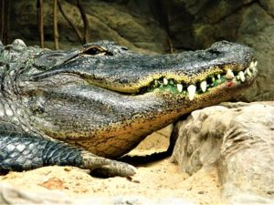

Class Aves
They are warm-blooded animals with the body being covered by feathers. The forelimbs are modified into wings. They have a four-chambered heart. They breathe through lungs. And they lay eggs. All birds are classified under this class. Examples are Parrot, Crow, and Ostrich.
Class Mammalia
Mammals are warm-blooded with a four-chambered heart. They have mammary glands. Their skin has sweat and oil glands. They give birth to young ones. Respiration occurs through lungs. Examples are human beings, gorilla, and cow.

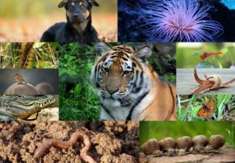

Concepts of species, hierarchial taxonomy

History of Species Concept:
The species, as we know, is the fundamental unit of taxonomic hierarchy. Davis (1978) called them ‘Building bricks’ in Biological classification. In biological phenomenon biosystematics concept is the oldest one. It is the lowest category of hierarchy which is consistently used and recognized by all the botanists. According to Stebbins (1977) is the basic unit of evolutionary process.
It starts with the great Philosopher Plato who proposed concept of eidos or species and believed that all objects are shadows of the ‘eidos’. Mayr (1957) suggested that variations in species are found arid presented on typological species concept.
Principle of logical division by Aristotle based in part upon Plato’s idea was the basis of Taxonomy serving as schema upon which “species concept” is based. Species was considered to be a relative term applicable to various levels in a classification scheme.
A logical relationship was also established between genus and species. Then species was defined on a priori basis and regarded as unchanging and fixed. After the knowledge of a number of organisms, people started facing difficulty as there are species which belong to different genera.
Various attempts have been made to define a species. Broadly; 5 different concepts are given:
(i) Nominalistic Species Concept:
It believes that “Nature produces individuals and nothing more”. (Linneaus species concept).
(ii) Typological Species Concept or Taxonomic species concept:
According to it species is “A very natural group of organisms hence a natural taxon in classification has an invariant generalized or idealised pattern shared by all members of the group”.

(iii) Biological Species Concept:
It was presented by Dobzansky in 1937. He suggested that “species is a group of interbreeding natural populations, that are reproductively isolated from such other group.”
(iv) Evolutionary Species Concept:
According to this concept, species is “a spatio temporal lineage of populations that evolves separately from other lineages and has its own ecological niche”.
(v) Ecological Species Concept:
It was suggested by L. Van Valen in 1976. According to it species is “A group of individuals maintained ecologically but not reproductively”.
The species concept kept on changing from time to time. Ernst Mayr 1963 stressed that the non-breeding of natural populations rather than the sterility of individuals be taken as the decisive species criterion.
Species as Individual:
After the knowledge of some monotypic taxa; philosophical problems, biological and evolutionary problems like gene flow etc. the questions arises as whether species might not better be regarded as individuals rather than classes.
The general accepted concept is, ‘species is a unit of taxonomic convenience, and that the populations, in the sense of a geographically constrained group of individuals with some unique amorphous characters, is the unit of evolutionary significance, ‘species is regarded as real by most of the taxonomists.
The hypermodern species concept by Platnick (1976) and Ghiselin (1976) defines species as “firms” in economic analogy.

Current Species Concepts:
A. Morphological Species Concept:
Morphologic species or Morphospecies concept is also called as classical phenetic species concept or Linnaean or classical species concept.
The concept suggests that:
(a) Species are the smallest groups that are consistently and persistently distinct and distinguishable by ordinary means.
(b) Species is easily recognized kind of organisms, and in macroscopic plants and animals their recognition should rest on simple gross observation (May be with hand lens only).
(c) A species is a community of a number or related communities, where distinctive morphological characters are one in the opinion of a competent systematist.
Morphological or classical species concept of readily recognized and morphologically defined species is practical and efficient system for information retrieval in most of the flowering plants.
his concept is useful and meaningful even for those plants where hybridization is common (e.g., Quercus).
B. Biological Species Concept:
This concept is held conceptually by most systematist at the present time.
It has two aspects:
(a) A group of interbreeding populations.
(b) Reproductively isolated from other such group.
Utility of this concept is that it deals with reproductive isolations. Krukeberg (1969) stressed that the bio-species also differ in their ecological contexts.
Love:
Love (1954) accorded species status to morphologically indistinguishable cytotypes.
Grant:
Grant (1966) used the biological species concept and created a new diploid species of Gilia (Polemoniaceae) experimentally through artificial relation over then generations in 16 years.
Mayr:
Mayr (1982) modified the definition of biological species concept to stress ecological aspects along with reproductive isolation and told that species is a reproductive community of populations (reproductively isolated from others) that occupies a specific niche in nature. However, Hengeveld (1988) criticized the use of word niche in definition as it is difficult to define it accurately.
The common criticisms of this concept are:
(i) Accurate determination of interbreeding among population.
(ii) Real extent of gene flow among population.
(iii) Common occurrence of interspecific hybridization between species of flowering plants.
(iv) Inapplicability of the concept to asexual species.
Hull:
Hull (1970) critically evaluated the biological species concept and found certain difficulties in using it. He felt that the numerical phenetic species concept has more problems, particularly on deciding which phenetic unit is the one to be called species.
C. Genetic Species Concept:
The genetic species concept assumes that the biological factors of gene flow and reproductive isolation are operative but the way to define species is by a measure of the genetic differences or distance among population.
It is the numerical phenetic species concept using a quantitative measure or genetic rather the morphological or other distance. The problem comes in knowing the genetic difference between populations.
Palmer and Zamir:
Palmer and Zamir (1982) for the first time studied the genetic distance from DNA sequence of chloroplast DNA.
D. Paleontological Species Concept:
Paleontologists work upon fossil species generally paleospecies or chronospecies in which arbitrary time limits are used to delimit paleontological species. Vaughan (1905) termed a collection of paleospecies in a monophyletic succession as genes. Paleospecies are usually time-oriented morphospecies.
E. Evolutionary Species Concept:
Evolution in genetical species keeps them sharply separate. Evolutionary species concept was advocated by Simpson (1961) who suggested that “An evolutionary species is a lineage” (an ancestral descendant sequence of population), evolving separately from others and with its own unitary evolutionary role and tendencies.
This concept avoids the difficulties with determining actual or potential levels of interbreeding as gene flow and allows some degree of inter-specific hybridization. Simpson (1961) also suggested that niche included multidimensional relationship of a taxon to its environment and not just its microgeographic situation.
Van Valen (1976) defined it as “A species is a lineage occupying an adaptive zone minimally different from that of any other lineage in its range and which evolves separately from all lineages outside its range.”
F. Cladistic Species Concept:
Wiley (1978) modified the evolutionary species concept and defined “A species is a single lineage ancestral descendant population of organisms which maintains its identify from other such lineages and which has its own evolutionary tendencies and historical fate”.
He stressed upon “historical fate” instead of “evolutionary role”. It is a shift from ecological view point to a historical context resulting from apomorphic changes within single branch of a cladogram. Donoghue (1985) and Mishler (1985) called it as phylogenetic species concept. Willis (1981) stated that each species is an internally similar part of a phylogenetic tree.
G. Biosystematic Species Concept:
It includes experimental taxonomic studies also. The variation taking place in reciprocal transplant and hybridization etc., are to be included successfully. Most common examples are Ecotypes, Ecospecies, Coenospecies etc.
Ecotype:
Closely, related but ecologically distinct population which are largely interfertile are called ecotypes.
Ecospecies:
Similar but hybrids between them are of reduced viability.
Coenospecies:
These are not interfertile at all (even artificially).
Those complex of species which cannot be sorted out taxonomically from a population and in which there is hope of eventual resolution are called species aggregate or Microspecies. Species group or Superspecies.
Many categories are proposed for interpretation of reproduction limits of taxa.
Camp and Gilly (1943) suggested at least 12 kinds, i.e.:
(a) Homoeneon,
(b) Phenon,
(c) Parageneon,
(d) Dysploidion,
(e) Euploidion,
(f) Alloploidion,
(g) Micton,
(h) Cleistgameon,
(i) Rheogameon,
(j) Heterogameon,
(k) Apogameon, and
(l) Agamenon etc.
Two of them are popular, i.e.,
(a) Homogameon:
“A species which is genetically and morphologically homogeneous and all members are interfertile”.
(b) Heterogameon:
“A species made up of races which, if selfed, produce morphologically stable populations, but when crossed many produce several types of viable and fertile off-springs”.
Apomictic groups are included in apogameon and agameon. Danser (1929) used the term comparium and commiscuum for coenospecies but was on the ability to hybridize and on geographic factors.
Heslop-Harison (1954) and Gilmour used Gamodeme (coenospecies) and Syngamodeme (Comparium) terms. Grant (1957) defined syngamone as the sum total of species of semispecies linked by frequent or occasional hybridization in nature, a hybridizing group of species, the most inclusive interbreeding population.
H. Multi-Species Concept:
It was given by Van Valen (1976). According to it ‘a set of broadly sympatric species (some region) that exchange genes in nature’ is called a species.
Compilospecies:
Compilospecies is one which is morphologically distinct (Taxonomic species concept) but not reproductively isolated (single species according to biological concept), e.g., Salvia mellifera and S. apiana which are morphologically distinct but reproductively not isolated.
Sibling Species:
The two species which are morphologically not isolated but reproductively distinct are called sibling species, e.g., Gillia inconspicua and G. transmontana.
Microspecies:
According to Grant (1981) Microspecies is the population of predominantly uniparental plant groups which are themselves uniform or slightly uniform and are differentiated morphologically from one another. These species are restricted to a limited geographical area.
The term microspecies was first introduced by Jord (1873) and often known as Jardanons in comparison to Linnaeons which are the normal species as suggested by Linneaus.
The species are capable of cross fertilization. Microspecies are of following types:
(i) Agamospermous microspecies:
The species reproduce by agamospermy, e.g., Rubus.
(ii) Autogamous microspecies:
The species are autogamous and chromosomally homozygous, e.g., Erophila.
(iii) Clonal microspecies:
The species reproduce only vegetative propagation, e.g., Phragmites.
(iv) Heterogamic microspecies:
The reproduction in the species is by genetic system, e.g., Oenothera biennis.
I. General Species Concept:
The species concept that is most acceptable for more sexually reproducing flowering plants is the biological concept. The reproductive barriers that keep species apart are most important for limiting gene exchanging and for maintaining the integrity of each unit.
The flow-chart determining population and species as suggested by Dayer and SlobodchiKoff (1974) is given below:
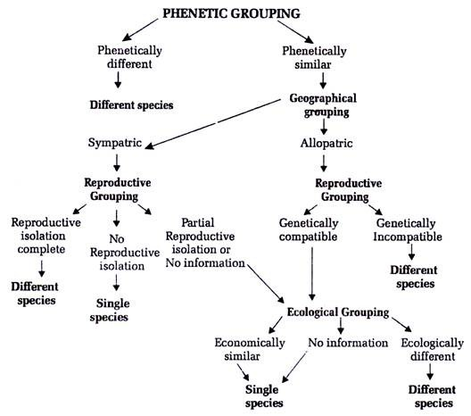
Unlike animals many plants hybridize freely in nature and are thus not reproductively isolated. In Epilobium (160 species) interspecific hybridization is very common. According to biological species concept the whole group is placed under complex species.
Any consideration of solution to the species problem now should consider that:
(a) All populations tend to vary and that no two are even alike.
(b) Some of these variations are adaptive and are of survival value.
(c) Forces of nature result in the extinction of some individuals while other survives the same force.
(d) Some of the variations shown by individuals within a population must be hereditary if successive generations are to be modified from the ancestral types.
(e) Environment of the individuals must not be static.
Population Concept:
Earlier the taxonomists were not knowing that the individual species possess certain degree of capacity for variation. They believed that taxonomy means that the description of a single plant is the description of the species to which it belonged. But now the scenario is quite different.
Now variation in the same species also has to be studied. So population study is a must. Mayr (1942, 47, 52) proposed the rule that we should name populations and not species, though an individual can be chosen as the nomenclatural type.
Population is the group of plants that grow in a particular habitat at a particular time. Several populations constitute the species. In such cases there are bound to be discontinuities between the different parts of the population. The more in dispersed such population systems are, the more will be difference between them.
A local breeding population growing together with inbreeding capacity to form a common gene pool is recognized by the biosystematists as the unit of evolutionary change.
Such ‘Panmictic’ population between whose members there is potentially free gene flow show variations in many features, even though they belong to the same species. Populations are therefore dynamic and show variations with in the population and variation between the populations of the same species.
Variations between individuals caused by factors like:
(a) Modification due to external environment,
(b) Mutation, and
(c) Genetic recombination.
Variation:
Variation is a deviation in structural, functional or developmental characters of an organism from its parents, from others in the same population.
Genotypic variation is the difference in genotype within population or species as a result of mutation, recombination or gene interaction with some evolutionary significance.
Phenotypic variation is variation in structural and functional characters resulting from environmental factors on one or more genotypes; this may not be of evolutionary significance.
Variety is the term applicable to diversity, variant population, variability, character variation etc. (Table 1).
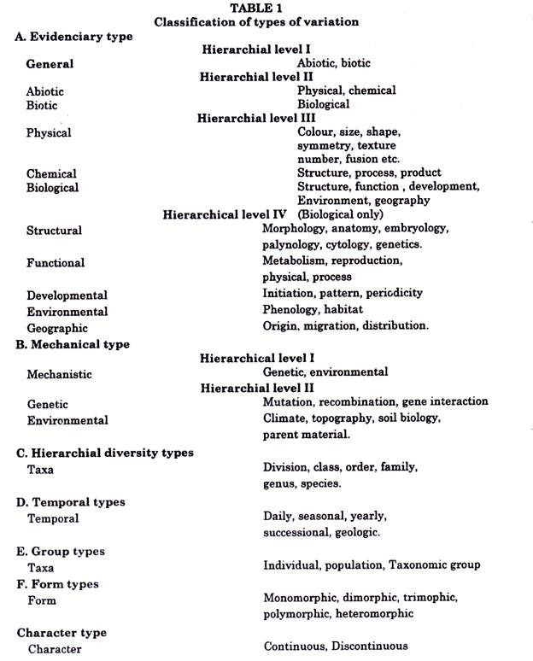
Variant is an individual or a group of individuals within a population that is definiable and recognizable. It is a neutral term used without taxonomic significance. Mostly the term is applied to an individual or group of individuals with one or only a few distinctive characteristics. It may or may not be equivalent of the taxonomic category or variety.
Diversity refers to a number of types of organisms or taxa in the plant kingdom. Total diversity of plant kingdom is approximately 2,50,000 (vascular plants). Among which 2, 35,000 are angiosperms, 600 gymnopserms and 10,000 pteridophytes. Diversity can be seen in various types also, e.g., in Rosaceae at least 9 fruit types are found.
Population Variability:
It is of three fundamental types, i.e., developmental, environmentally induced and genetic variation. Developmental variability can be seen in Oak (Quercus).
Where in Scarlet Oak (Quercus coccinia) the leaves on adventitious shoot (Sucker) are similar to normal leaves of Red Oak (Q. rubra) whereas, the leaves on shaded sucker shoot, of turkey Oak. (Q. leavis) are similar to sun (normal) leaves of scarlet oak). Other example is of Bean plant where the first leaves are opposite and simple which later on become alternate and pinnately compound.
Genetic variation in the population is the result of mutation and recombination. Mutation may be as small as substitution of single nucleotide pair in the DNA molecule or as big as chromosomal aberration (structure or number).
Recombination is a reassortment of chromosomes, crossover segments etc. It generally takes place in meiosis and fertilization. It results in hybrid formation, pollination, dispersal, population size etc. Recombination also results from hybridization and introgression. Introgression is process of successive hybridization causing the migration of genetic material from one species (infraspecific) into another.
Character variation in plants is fundamental to taxonomic training and research.
Speciation:
Speciation is the process by which new species are formed from other ancestral ones. The most widely accepted hypothesis explaining the process of speciation is the geographical theory of speciation or allopatric theory of speciation. According to it the first step in speciation is reproductive isolation brought about by physical separation or geographical separation of population (allopatric population).
Separation results commonly from shrinkage of the original range of a species so that the populations become physically isolated. Separation may also results by large range or dispersal when new populations become established beyond the range of pollination of original gene pool.
The second step is the independent differentiation and evolution of these reproductively isolated populations. Eventually, if the ranges of the populations merge again and the reproductive isolation persists, then the speciation process is considered complete.
Due to first step in differentiation ecotypes are formed. Agrostis tenuis, a temperate grass which also grown on lead concentrated soil, and becomes lead tolerant.
This character is not lost even in the absence of the metal. If the two populations grown side by side, may cross and produce hybrids that cannot tolerate the lead concentration on one side or cannot compete with the normal plants of the species on the other side. Lack of hybrid survival constitute – absolute barrier to gene exchange.
Speciation may take place abruptly also by development of polyploids and mutations Futuyma (1983) suggested that “Speciation more thoroughly a wash in unfolded and often contradictory speculation than any other single topic in evolutionary theory”.
Isolating Mechanism:
There are many isolating mechanisms which operate to prevent or reduce the gene flow between populations:
(a) Reproductive Isolation:
It depends upon some aspects of plants themselves such as lock and key pollination mechanism, difference in flowering time of the two populations etc., e.g., Salvia apiana and S. mellifera are two species growing in different zones but show resemblances also. S. mellifera blooms in April, smaller flowers pollinated by smaller bees, flies and butterflies, while in S. apiana the flowers are large and pollinated by larger carpenter bees. S. apiana grows in drier soil. According to Stace (1989) the two species are separated by the ecological and mechanical differences.
(b) Spatial Environmental Isolation:
It is also known as geographic isolation. According to Grant (1981) “Spatial or geographic isolation exists between any allopatric species whose respective geographical areas are separated by gaps greater than the normal radius of dispersal of their pollens or seed”, i.e., Liriodendron tulipifera of Eastern United State and L. chinense of South eastern Asia, which cannot breed under natural conditions but have been crossed artificially.

Types of Species:
Grant (1981) recognized 5 types of species along with Evolutionary species of Simpson (1961):
(1) Taxonomic species:
(Morphological species, phenetic species) The taxa, group of morphologically similar individuals.
(2) Biological species: (Genetic species):
Sexually reproducing population system.
(3) Microspecies: (Agamospecies):
Population is uniparental organism.
(4) Successional species: (Paleospecies):
Phyletic lineage.
(5) Biosystematic species: (Ecospecies, Coenospecies):
Fertility group.
(6) Evolutionary species:
Combined sexually reproducing populations iniparental groups and phyletic lineages.
Taxonomic Hierarchy:
To achieve the ranking in Taxonomy a hierarchy of categories is suggested. It was Linnaeus (1753, 1754) who for the first time suggested such hierarchy and so it is known as Linnaean Hierarchy. It was developed long before the knowledge of evolution during 15th or 16th centuries. Species is the fundamental unit of it.
Linnaeus hierarchy was slightly modified over the years and is as follows:
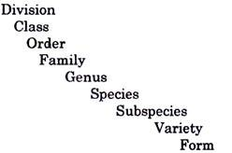
Now many intermediate categories are included in it such as subfamily, sub genus, section, tribe etc.
The Linnaean hierarchy is viewed as system of classes within classes and named nested classes by Buck and Hull (1966). In Linnaean hierarchy category means a particular level or rank in the taxonomic hierarchy, e.g., genus or class, and taken collectivity all these available categories represent all the different levels. Taxon means a cluster of individuals grouped together based on the sharing of features in common. The taxa are referred to particular categories, e.g., species or variety available in the hierarchy.
In the accepted system of nomenclature every individual plant is treated as belonging to a number of taxa of consecutively subordinate ranks; each with subcategories or taxa of consecutively as ascending rank e.g., an individual plant of swamp rose would belong to the consecutively higher ranks of the species.
For example : Ranunculus muricatus species is muricatus, Genus is Ranunculus, Family: Ranunculaeae, Order: Ranales: Class: Magnoliopsida and Division: Magnoliophyta, according to recent system of classification. The suffix for each rank is different, e.g., aceae suffix shows a name of family.
Conceptually, the ranks of taxa cannot be defined precisely, just arranged hierarchically. A group of plants, however, can be circumscribed and delimited as named ranks, e.g., rose in the genus Rosa. Asters for the genus Aster. Natural groups are treated as ranks at the generic, familial and higher categories, e.g., Pines (Pinus), Oaks (Quercus), Clover (Trifolium).
The only Taxonomic group with an inherent rank in the species aside from intraspecific taxa.
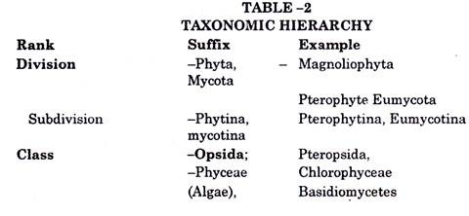
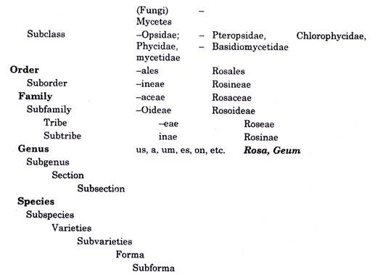
The name of an infraspecific taxon is a combination of the name of a species and an infraspecies epithet connected by a term denoting its rank. Infraspecific epithet is formed as those of species and, when adjectival in form and not used as substantives, they agree grammatically with the generic name, e.g., Saxifraga aizoom var, aizoom, subvart, brevifolia forma multicaulis subforma surculosa Engler and Irmschen or Saxifraga aizoom subforma surculosa, Engler and Irmschen.
Infraspecific Ranks:
Linnaeus used only one infraspecific taxon, the variety. But over the years various taxonomists used a number of infraspecific ranks in their respective Flora. International Code of Botanical Nomenclature recognizes five infraspecific Ranks, Subspecies, Variety, Subvariety, Form and Subform.
But many workers found it to be insufficient and well over 100 different infraspecific ranks have been proposed time to time. Now-a-days only three of the five suggested by ICBN are in use. Subvariety and subform are largely abandoned.
The definitions of the three infraspecific ranks as given by Du Rietz are:
Subspecies:
“A population of several biotypes forming a more or less distinct regional facies of a species”. It is thus a geographical race, ecotype, topodeme or genoecodeme.
Variety:
“A population of one or several biotypes, forming more or less distinct local facies of a species”. It is thus a local or ecological race, an ecotype genoecodeme of a lower order, or an Ecodeme.
From:
“A population of one or several biotyes occurring sporadically in a species population in one or several distinct characters”. It is thus a genodeme orrelatively minor genetic variant occurring mixed with other such distinct variants.

Family and Higher Categories of Species Concept:
In classification, the categories considered at the higher level are family, order class, division and kingdom.
Kingdom:
It is the largest group or population which is well defined, traditionally as Plant and Animal. But Whitekar (1969) suggested a 5 kingdoms classification and divided all the living organisms into 5 kingdom, i.e., Monera, Protista, Fungi, Plantae and Animalia.
Very recently a new or sixth kingdom also has been included by Yarg, Kaine and Woese (1985) who considered very primitive methane Bacteria discovered by Woese and Fox (1977), Fox (1977) into this separate kingdom.
Division:
Previously Eichier (1883) proposed Algae, Fungi, Bryophyta, etc as divisions. Bold and Wynne (1985) divided Algae into many divisions, i.e., Chlorophyta, Rhodophyta, Phaeophyta whereas, Cyanophyta is now treated as Cyanobacteria and is placed in division Monera. Lewin (1981), divided algae into prochlorophyta (Prokaryotic algae).
In angiosperms which were traditionally divided into dicot and monocots, Dicots are called as Magnoliophyta by Cronquist, Takhtajan and Zimmermann etc. (1966).
Bremer and Wanntorp (1978) recognised six “major groups” based on a cladistic reinterpretation of Takhtajan’s (1969) phyletic classification.
Orders:
In Angiosperms Orders are not well defined except for a few such as Caryophyllales. Cronquist, Throne, Takhtajann and Dahlgreen etc., used orders in various ways.
Family:
Different workers put stress on certain families only. If we look into the history of it, we can see that since the time of Theophrastus the families were there but were named on the basis of their similarities, e.g., mints (Labiatae) or carrots (Umbelliferae) etc. Tournefort (1700) attempted to make informal groups of genera with some similar characters and tried to describe them.
Linnaeus (1753) also has not used any term as family. The term ‘family’ was first used by A.L. de Jussieu in his Genera plantarum (1989) where he grouped the genera under one head, i.e., family. A.L. de Jussieu is also known as “Father of the familial concept” in flowering plants.
Genus:
Genus is next to species as far as taxonomic hierarchy is considered. Though there are many intervening categories as series, section, subgenus etc., as suggested by ICBN but they are not fundamental units. Sub-sections are good and helpful when a genus has a large number of Species (Infra generic), e.g., Senecio (Asteraceae) has more than 1,000 species.
According to Robinson a genus is a group of species which from likeness point of view appear to be more nearly related to each other than they are to other species.
The concept of Genus is the oldest among all taxonomic categories. Since very early times the plants in groups were named as Elms, Poplars, Willow, Pines, Oaks, Roses, Palms, etc. Tournefort (1700) used 698 genera of plants, Linnaeus (1737) about 935 genera etc., So it was very difficult to remember all of them.
The necessity of grouping them in accordance with their characters arose and family concept had taken birth, Jussieu (1989) recognized 100 families but now modern taxonomists recognize more than 400 families.
Tournefort (1700) is known as “Father of generic concept”. He proposed that out of six features of a plant, i.e., root, stem, leaves, flower, fruit and seeds, at least 5 should be considered for generic circumscription.
Linnaeus in Philosophia Botanica (1751) used 3 characters for generic concepts, i.e.:
(a) Natural character (complete description of plant).
(b) Factitious character (selection of certain characters suitable for discrimination among genera in an artificial system of classification).
(c) Character essentials (characters allowing easiest description).
According to the nomenclature code the generic name is a uninominal singular word and should be a noun. It may be masculine, neuter or feminine (-us and -pogon) are masculine; -um is neuter and -a (are for feminine genera). The first letter of the generic name should be written in Capital letter of English.
The generic name may be:
(i) Name of a Person (Commemoration):
The name is dedicated to a person e.g., Bauhinia (for Bauhim); Fuchsia (for Fuchs), Victoria (for Queen Victoria), Dillenia (for Dillinius), Linnaea (for Linnaeus), Collaea (after Colla) and Ottoa (alter Otto) etc.
(ii) Name of a Place:
The generic name is after a place such as Arabis (for Arabia), Salvadora (for EL Salvadore) etc.
(iii) Name of a character:
The generic name may be based on an important character of the plant, e.g.,
Hepatica for liver like
Acanthus for spiny
Hygrophila for marshy plant.
Trifolium for trifoliate leaves etc.
(iv) Aboriginal name:
The name is directly adopted from a language other than latin, e.g.,
Ginkgo:
Chinese language
Vanda:
Sanskrit language
Narcissus:
Greek language
Sasa:
Japanese language etc.
Generally, the name should be in Latin language. The generic name of a tree ends with -us as tree is considered to be feminine, e.g., Pinus, Quercus, Cedrus, Pyrus, Prunus etc. A generic name cannot be a technical term used in morphology unless it was published before January 1, 1912. The generic name should be accompanied with a specific epithet following the binomial system of Linnaeus.
According to ICBN Generic name should comply the following:
(1) To use Latin termination in so far as possible.
(2) To avoid names not readily adaptable to the Latin language.
(3) Not to make names which are very long and difficult to pronounce in Latin.
(4) Not to make names by combining words from different languages.
(5) To indicate, if possible, by the formation or ending of the name the affinities or analogies of the genus.
(6) To avoid adjectives used as nouns.
(7) Not to use a name similar to or derived from the epithet in the name of one of the species of the genus.
(8) Not to dedicate genera to person quite unconnected with botany or at least with natural science.
(9) To give feminine forms to all personal generic names, whether they commemorate a man or woman.
(10) Not to form generic names by combining parts of two existing generic names, because such names are likely to be confused with nothogeneric names (Hybrid names).
Species:
Species is the fundamental unit or category of taxononomic hierarchy. According to Davis (1978) it is the building bricks in biological classification. Species category is one of the oldest concepts used historically by people.
It is the lowest category in the hierarchy that is consistently used and recognized by all people of the world. Concept of species was used by Plato (a philosopher) for the first time in terms of eidos. After many years (Aristotle) species was defined on an a priori basis and was regarded as fixed and unchanging.
John Ray in his Historia Plantarum presented species concept (1668- 1704). Davis and Heywood (1963) suggested that any change in the species is due to environmental factor or inherent factors.
According to Cytogenetists (Shull) “The species are only quasi-natural entities’.In Microorganisms the species is not a valid concept. There the unit is called strain.
In binomial nomenclature, the first epithet of the name is generic and the second epithet is specific. All specific epithets should begin with small letter of English. The specific name may be pronoun, adjective etc.
It may be:
(i) Name of a person:
It may be dedicated to the name of a person, e.g., sahnii (for Prof. Birbal Sahni). roylei (for Royale); hookeri (for Hooker) etc.
(ii) Name of a place:
The name of the place should be an adjective ending with -ens, -ensis, – cumor -cus or -iana etc. e.g., kashmiriana, indicum, indicus, canadensis, nepalensis, nepalens, etc.
(iii) Name of a character:
The character may be represented as alba (for white flower); sativa (edible nature) etc. Depending upon the gender it may be alba, album or albus or sativa, sativum or sativus etc.
ADVERTISEMENTS:
(iv) Noun in apposition:
Sometimes the specific epithet carries its own name, e.g., in Pyrus malus. Malus is the Greek name of apple and in Allium cepa, cepa is the Latin name of onion.
Generally, the specific epithet is of one word but if it has two words then a hyphen (-) should be placed in between, e.g., Hibiscus rosa-sinensis; Capsella bursa-pestoris etc.
Till recently, species was thought out to be the smallest unit of (Taxa) taxonomic ranks. But now subspecies and varieties are also available. The names of subspecies are trinomial, the third epithet being of subspecies. A variety may be quadrinomial as the fourth epithet will be for varieties but in case there is no subspecies, it will be trinomial, e.g., Brassica oleracea var. capitata.
According to ICBN. specific epithets should comply the following:
(i) To use Latin terminations insofar as possible.
(ii) To avoid epithets which are very long and difficult to pronounce in Latin.
(iii) Not to make epithets by combining words from different languages.
(iv) To avoid those formed if two or more hyphenated words.
(v) To avoid those which have the same meaning as the generic name (pleonasm).
(vi) To avoid those which express a character common to all or nearly the species of a genus.
(vii) To avoid in the same genus those which are very much alike especially those which differ only in their last letters or in the arrangement of two letters.
(viii) To avoid those which have been used before in any closely allied genus.
(ix) Not to adopt epithets from unpublished name found in correspondence, traveller’s notes, herbarium labels, or similar sources, attributing them to their authors, unless these authors have approved publications.
(x) To avoid using the names of little known or very restricted localities unless the species is quite local.

